September 27, 2018

IMPORTANT INFORMATION ABOUT YOUR DRINKING WATER
Saluda County Water and Sewer Authority (SCWSA) recently violated a drinking water standard. This incident was not an emergency, if it had been an emergency, you would have been notified within the first 24 hours after the violation. Although this is not an emergency, you, as our customers, have the right to know what happened, what you should do and what we are doing to correct this situation.
SCWSA is required to monitor your drinking water for the presence of disinfection byproducts (DBPs) on a quarterly basis. DBPs can form when a disinfectant (chlorine) reacts with natural organic matter in the water. Total trihalomethanes (TTHM) is a disinfection byproduct.
The DBP test results from the last four quarters that ended on September 30, 2018, show that our system exceeds the standards, or maximum contaminant level (MCI), for total trihalomethanes (TTHM). The MCL for ITHM is calculated based on a locational running annual average (LRAA). The LRAA of ITHM at a sampling location about 3 miles from Ridge Spring is at 85 parts per billion (ppb). This exceeds the respective MCL for of 80 ppb.
TTHM forms over time based on pH, chlorine concentration, temperature and water age. The MCL was exceeded at a sample point on one of the far ends of our water system as is one of the furthest points from where SCWSA receives its water. Consequently, the water sampled from this point has a long residency time in our system which can lead to the formation of TTHM.
People who drink water containing TTHM more than the MCL over many years may experience problems with their liver, kidneys or central nervous system and may have increased risk of getting cancer. With that said, there are no precautions you need to take. You do not need to boil your water or take any corrective action.
SCWSA is constructing a new water treatment facility where we will treat water from Lake Murray and distribute it to our customers. This new treatment facility will come on line in the fall of 2018 and will afford us much more control of the parameters that affect DBPs in our water.
Please share this information with anyone you know that also drinks the water, especially those who may not have received this notice. If you have any questions, please contact me, Jason Fell (General Manager) at 864445-9572. Thank you for your patience and understanding with this matter. This notice is being sent by the Saluda County Water & Sewer Authority (SCWSA); our SC Water System ID is 4120001.
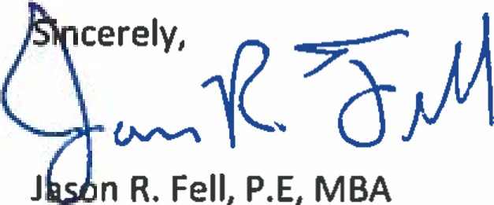
l

Saluda County Water & Sewer Authority
General Manager

