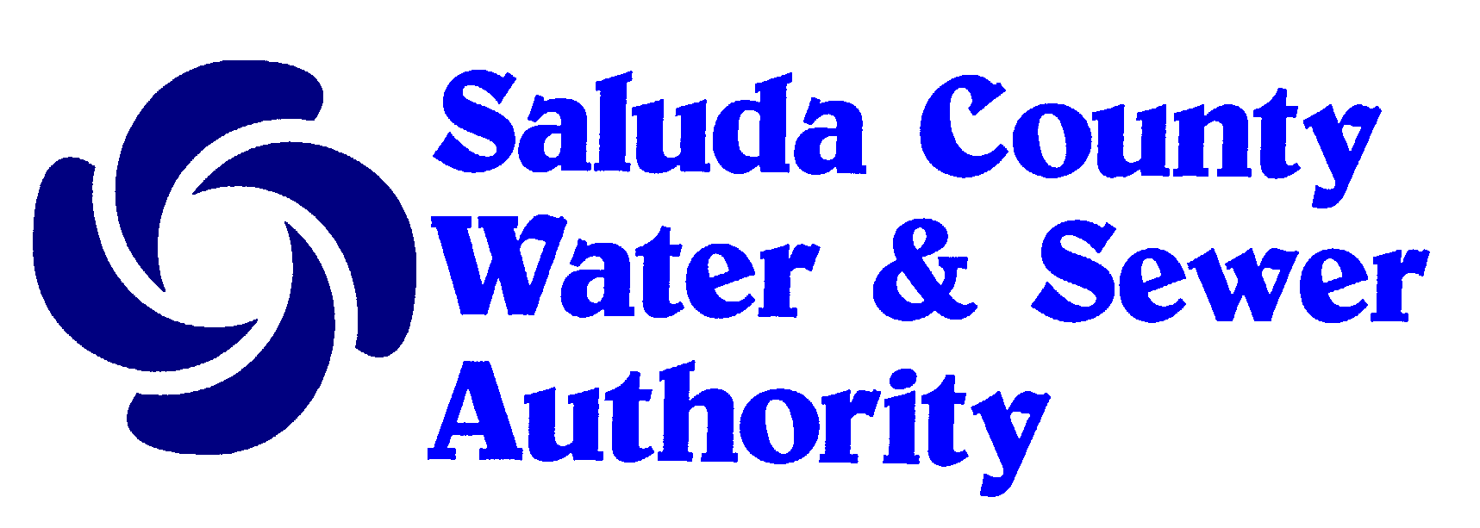106 North Jennings Street
Saluda, South Carolina 29138
Telephone: 864 445 9572

PROPERTY OWNER WATER SERVICE REQUEST

PRIMARY CONSUMER IS:
CHECK ONE ONLY

White | Black or African American | American Indian or Alaskan Native | Native Hawaiian or Pacific Islander | Hispanic or Latino | Asian

PRIMARY USE IS:
CHECK ONE ONLY

Residential | Commercial | Agricultural | Industrial

IS THIS A RENTAL PROPERTY? Yes No

NAME
MAILING ADDRESS

CITY STATE ZIP CODE
HOME PHONE WORK PHONE CELL PHONE
SOCIAL SECURITY NUMBER
DRIVERS LICENSE NUMBER STATE
EMAIL ADDRESS

911 SERVICE ADDRESS

LOCATION OF PROPERTY (IF NOT ALREADY ON THE SCWSA WATER SYSTEM)

PLEASE INCLUDE A TAX MAP NUMBER OR PLAT. IF THE TAX MAP NUMBER AND PLAT ARE UNAVAILABLE, PLEASE SKETCH IN A MAP OF PROPERTY LOCATION USING ROAD NAMES OR NUMBERS. YOU MAY ALSO USE LANDMARKS SUCH AS CHURCH’S, BUSINESS’S ETC.

SIGNATURE ____________________________________________ DATE ________________________

This institution is an equal opportunity provider and employer.

